**UNHINGED BUT NOT CRAZY**

By Aleksandra Czekala

DMC3003 SOCIAL MEDIA MARKETING

Industry Report

**Introduction**

The concept of unhinged marketing, according to Emily Lynch, a marketing consultant, is so difficult to define that professionals have trouble doing that. Among the words she tried to describe it were chaos, deranged, unstable, or, more formally, “breaking the fourth wall and leaning into the language of the internet to appear relatable and human-like.” Ultimately, unhinged marketing makes a brand and the firm behind that brand some*one* rather than some*thing*. While the concept is known among those who use social media in its various forms as the centrepiece of their marketing efforts, it is still so new and niche-specific that the search term “unhinged marketing” used in Google Scholar, the Google subsidiary specialising in peer-reviewed academic articles, and Jstor, a private archival operation with thousands of academic and professional journals in its data banks, returned no hits. Among the best examples of a successful unhinged marketing campaign is the language teaching application *Duolingo*. This report will investigate the success of *Duolingo* and, as part of it, the history and development of unhinged marketing.

**In the Beginning**

Unhinged marketing can be traced, according to Lynch (2023), to an exchange between Wendy’s hamburger chain and a Twitter troll that took place in late 2016 and blended into 2017. Wendy’s was famous for creative marketing, and its “Where’s the Beef?” campaign became one of the most widely recognised catchphrases of the 20th century (Logie, 2020). But by 2016, they were working to regain the market share the company had lost and struggling to do so. Then came a Twitter exchange that put them back on the map. The exchange as a whole can be seen [here](https://www.cosmopolitan.com/food-cocktails/a8557173/wendys-epic-clapback-to-a-twitter-hater-is-the-2017-inspiration-you-need/) (Bruk, 2017). The “elevator version” is that Twitter user “@NHride” reacted to Wendy’s post: “Our beef is way too cool ever to be frozen.” @NHride asserted that Wendy’s did use frozen beef. The exchange went on for a week. @NHride made a mistake when he [Author’s note: In the absence of affirmative evidence to the contrary, it is fair to assume the protagonist is male.] brought McDonald’s into it, asserting McDonald’s had won the “breakfast market” with its “dope ass breakfast”. Wendy’s ended the exchange with this knockout blow - “@NHride You don’t have to bring them into this just because you forgot refrigerators existed for a second there (Ibid.).” Game, set, and match when @NHride deactivated the account.

According to at least one professional Internet marketing consultant, Wendy’s exchange marks the beginning of “unhinged marketing.” As Generation Z, those born since 1997, according to the widely respected Pew Research Center (Dimock, 2019), is entering their peak earning years, they have become the primary target of marketers regardless of the product or service being promoted. In Lynch’s analysis, the viral reaction to Wendy’s smackdown was an epiphany for marketers. The concept of a “sassy” brand was attractive. The idea that corporations could be engaging and fun became a valid marketing program. Brands that are “stodgy” are poison to Generation Z consumers.

Indeed, those consumers just entering their peak productive and consumption years are the *primary* target for marketing managers and staff. The problem marketers face is that this generation is less likely to be affected by traditional marketing and advertising. Generation Z relies on streaming services for entertainment, and the “skip” or “fast forward” buttons are always there to get past unwanted advertisements. They use ad blockers attached to their search engines, inhibiting that particular form of advertising. They are often prepared to pay for “premium,” which is to say “ad-free,” services from sites they are interested in. Generation Z relies on social media, Facebook, TikTok, X, and the rest for social interaction and count among their “friends” who are unlikely to ever encounter in the real world. Even traditionally “non-social” functions, such as learning the news and finding reviews on virtually anything, are found on various social media by Generation Z (Siu, 2022). When the Wendy’s vs @NHride exchange went viral on social media, marketers realised they had a way to get to Generation Z on the platforms with which they are familiar.

**Duolingo’s Unhinged Approach**

Duolingo was formed in 2011 as a partnership between Luis von Ahn, a professor at Carnegie Mellon University, and a graduate student, Severin Hacker (von Ahn and Hacker, 2024). The founding concept was to provide free language education. Von Ahn, who created the bot-blocking system Captcha, was raised in Guatemala and experienced the high cost of learning English. When he sold *Captcha,* he had money and set out to provide a free service for anyone to learn English. From the beginning, Duolingo used a unique business model. While teaching English, Duolingo students worked on translating Wikipedia articles from the web (“Language Learning Made Free:..., 2023).

The founders released the Beta version of Duolingo in June 2012, when a third of a million subscribers were waiting. While the professionals in marketing, and especially those who focus on the use of social media as a marketing vehicle, see the famous Wendy’s exchange with @NHride noted above as the opening salvo in the new field of unhinged marketing, a strong case can be made for Duolingo as the true pioneer (Ibid.). From the beginning, Duolingo's success has resulted from savvy internet use.

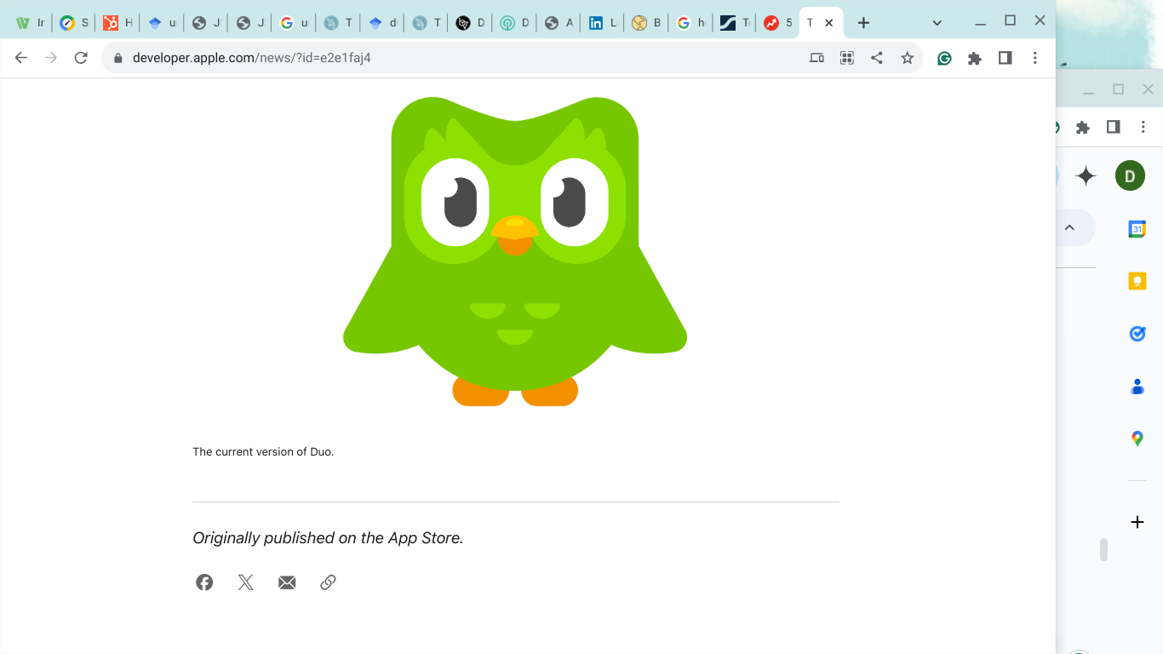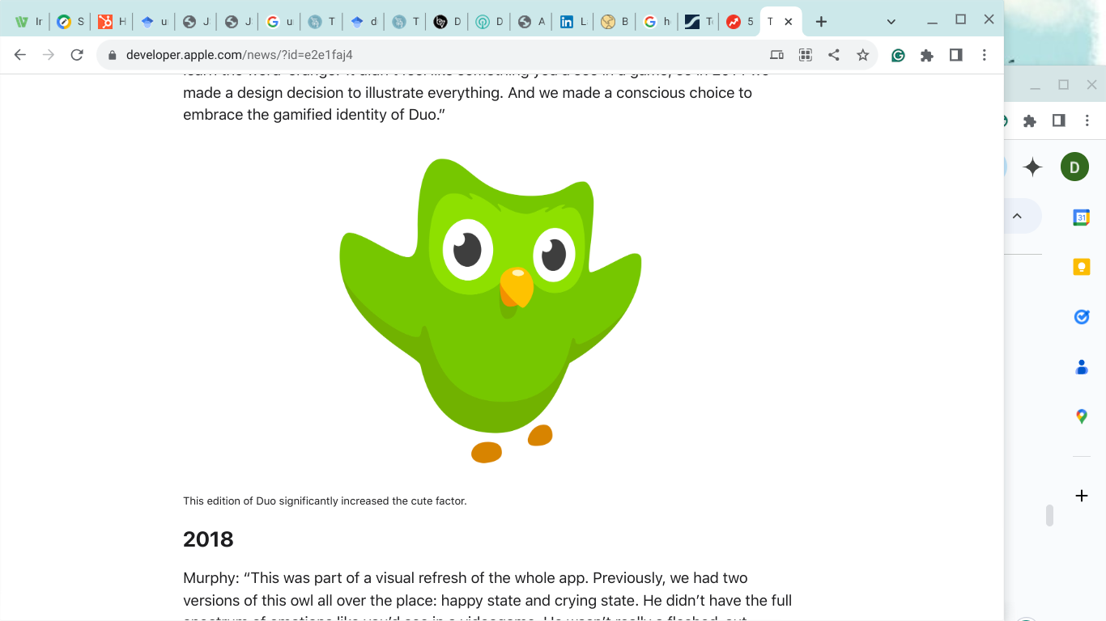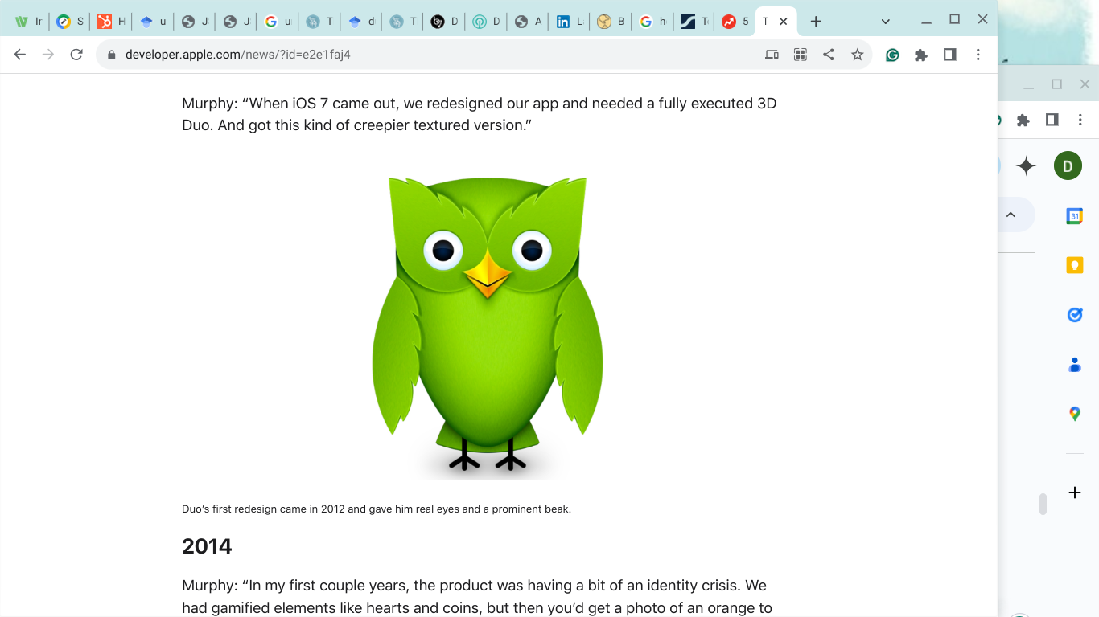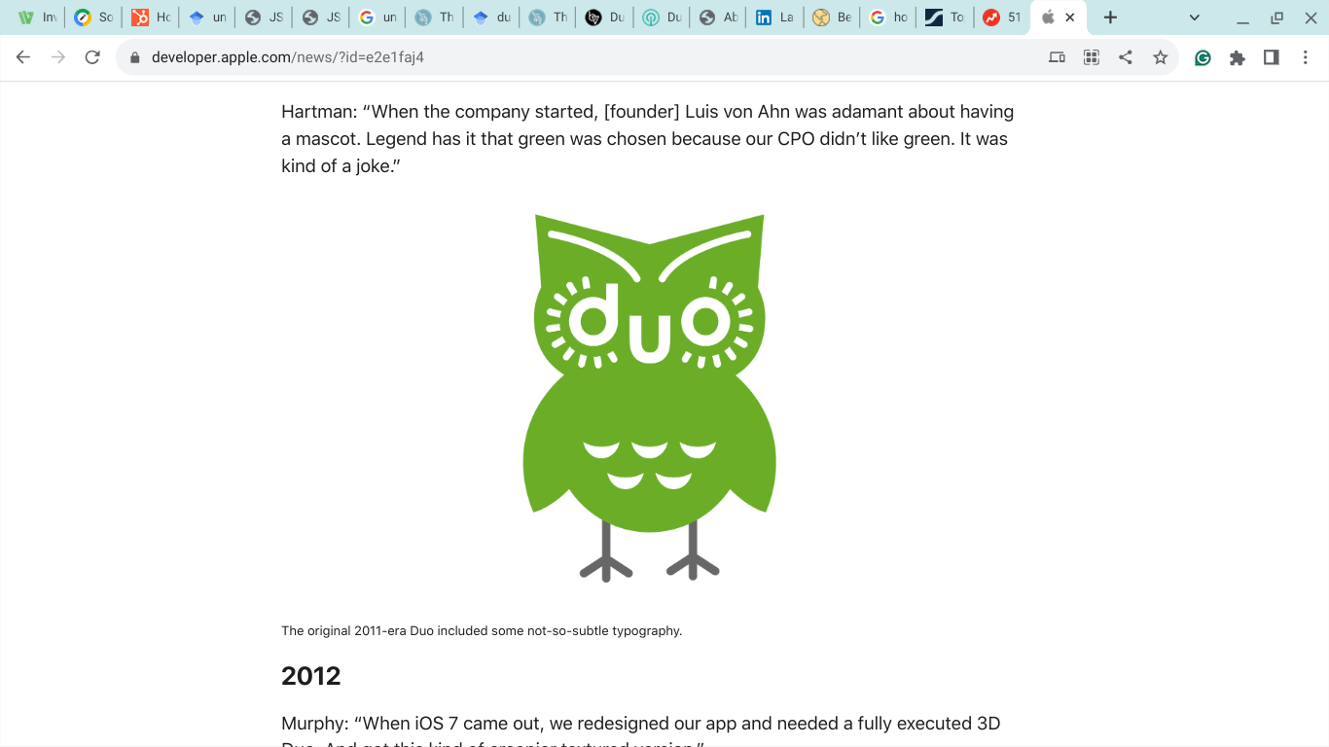Duolingo has a recognised “mascot,” Duo, who provides the focus for the company’s unhinged marketing approach. The Duo is a cartoon owl. Over the years, the green owl has morphed from the original stylised owl with the word “duo” worked in as beak and eyes to an even more realistic version of a green owl (always green because legend has it, the Chief Production Officer hated the colour green, to a much more cartoonish and much less detailed, still-green owl, to the even more basic duo owl that new users today find encouraging, sometimes bullying, nagging, constantly cajoling and reminding the new student, primarily if he (throughout this paper the male pronoun is understood to include the female to avoid awkward gender inclusive constructions such as “he or she,” “him or her,” “his or hers,” or the like) misses a day (“The Evolution of the Duolingo Owl,” 2020). Duo greets new users each time they visit, and the mascot encourages them to keep at it. If a new student misses a day, Duo drops a text message and an email reminder (Scacchi, 2023).

Indeed, the centrepiece of Duolingo’s success is a light-hearted approach to presenting profound and compelling content. Marco Scacchi of Sensor Tower, a commercial firm specialising in measuring results of internet marketing projects, has called this the “gamification” of Duolingo (2023). The “gamification” has resulted in an exceptionally high product “stickiness.” In Scacchi’s analysis, this “stickiness” means that Duolingo’s students have three essential characteristics;

1. They “stick” with the program. Game-like features - bonus “points” for “streaks” when students return day after day, scorekeeping, and promotions to higher social “levels” are essential in promoting stickiness.
2. Loyalty. Duolingo students are far less likely than participants in other online language learning systems to try different systems. Limited use of multiple apps places Duolingo at the head of the group in this important metric.
3. Power Users. With the latest revisions to the platform in 2022, including improved “gamification features,” the number of power users, defined as students who open the app 15 times a month, jumped from 20 per cent of students to 30 per cent, giving Duolingo a high rate of “regulars.” The converse, “churn,” defined as those who open the app one month and then fail to do so the following month, declined from almost half (47 per cent) to a little over one-third (37 per cent) (Scacchi, 2023).

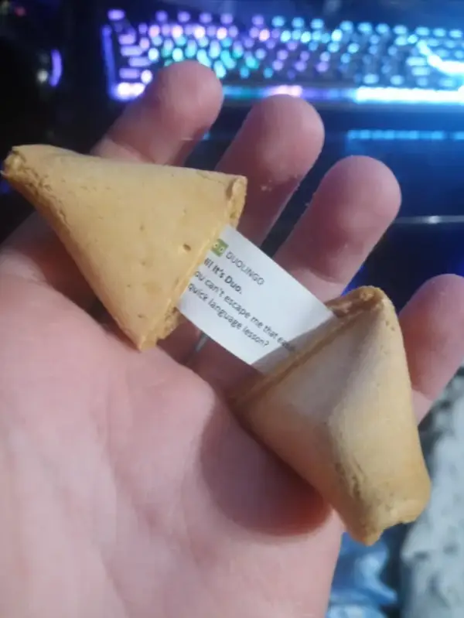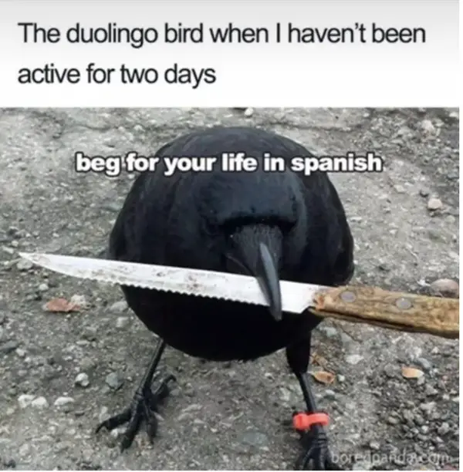Besides the “gamification,” Duolingo’s owners were early to understand the potential of social media marketing. They were among the first to master the potential provided by the “memes,” those sharable chunks of society that can go viral and bring a product or a service to the attention of millions in a few hours (Benveniste, 202). Images like the one to the right get a smile and make the uninitiated ask, “What the heck is Duolingo?” Or the one below. It makes anyone smile, even those who don’t know what Duolingo is. One is left to wonder how many saw the fortune cookie warning and went immediately to Google, well, after they quit laughing, to see just what this Duolingo thing is that is so persistent it can track you, like a character in a Dean Koontz novel, to the Chinese restaurant to which you had no idea you were headed that evening (Images from Martinez, 2023). Duolingo drops these memes regularly, driving social media attention and keeping those critical Generation Z internet addicts interested.

**Target Audience**

Duolingo has strategically positioned itself to cater to individuals eager to learn new languages but may need more financial resources to enrol in traditional language courses. This demographic predominantly comprises Gen Z and millennials, ages 16 to 34.

To connect with this audience, Duolingo has personalised and gamified the learning experience and cultivated a playful online presence across various social media platforms. This approach has effectively engaged the younger, social media-savvy population, contributing significantly to the brand's remarkable buzz today.

Duolingo's substantial user base and swift expansion indicate that its social media strategy has been highly effective. TikTok has been instrumental in propelling Duolingo to prominence and continues to be a key channel in its marketing efforts.

Rather than sticking to conventional educational content and typical influencer collaborations, Duolingo opted for a distinct approach. They developed a uniquely quirky and entertaining social media persona that captivated, surprised, and delighted their audience, setting them apart in the digital landscape.

**Social Media Strategy**

In its strategic approach to social media, Duolingo has mastered the art of staying relevant and engaging by actively participating in current trends and discussions. A prime example of their innovative strategy was during the "Barbie" craze last year when Duolingo introduced a TikTok video featuring their mascot, Duo, whimsically placed in Barbie Land. The video humorously suggested that Greta Gerwig, the movie’s director, had chosen Duo to replace Margot Robbie. This audacious and unique spin on the trend captured the essence of the viral conversation and catapulted the video to viral status, amassing over 3 million likes and 242,000 shares. This epitomises Duolingo’s ability to blend trending cultural moments with its brand identity, creating compelling content that resonates widely and deepens engagement with its target audience.

Additionally, Duolingo's approach to making educational experiences enjoyable has proven crucial in its success on social media platforms. Their strategy, often described as "candy with the medicine," ingeniously combines entertainment with language learning, engaging users by making the educational process fun. This method has resonated well across various social media channels, significantly increasing user interaction and commitment to the brand.

In content creation, Duolingo employs the Flicker, Flash, and Flare techniques to ensure their posts are not only seen but are memorable and shareable. This approach highlights their innovative use of media to capture and sustain the audience's attention. Moreover, the brand's A screenshot of a phone
ability to weave continuous narratives through its content, such as the playful rivalry with Google Translate, provides followers with ongoing storylines that enhance engagement and foster a sense of community among users. These stories encourage users to return, eager to see the latest developments in Duolingo's cleverly crafted social media saga.

Duolingo's effective use of its mascot, Duo, further exemplifies its creative approach to engagement. By giving Duo a life of its own — complete with humorous adventures like getting a Brazilian Butt Lift — Duolingo keeps content fresh and highly engaging. The whimsical nature of these posts plays into the persona of Duo, making it not just a mascot but a beloved character that fans look forward to interacting with.

This consistent and audience-centric approach is critical to Duolingo’s successful engagement on social media. Duolingo captivates and cultivates a loyal community of learners by actively participating in conversations, responding to user-generated content, and maintaining an entertaining and interactive presence. Each interaction is designed to enhance the user's experience and reinforce the brand’s presence as an integral part of the online language learning community.

**How Good Is It**

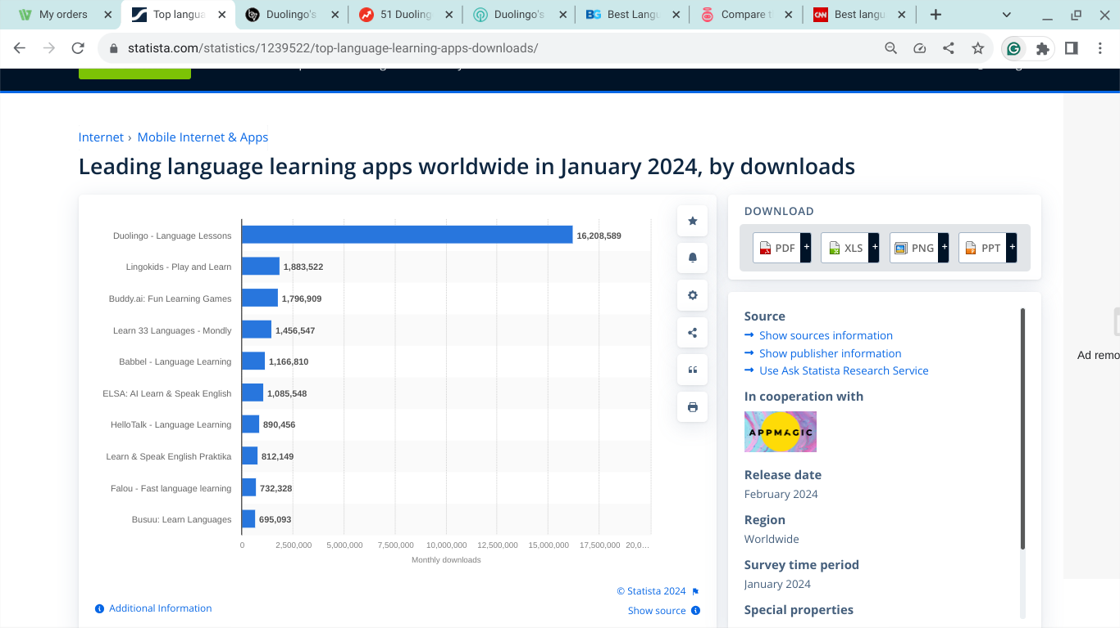Duolingo's success as a marketing experiment is beyond question. One need only look at the numbers. As shown in Exhibit No. 1, Duolingo outpaces the next most widely used language learning app by almost 10 to one. Indeed, Duolingo has more users as of January 2024 than the next nine widely used apps combined.

**Exhibit No. 1**

**Comparison of Market Penetration by Language Learning Apps**

While there is no doubt that Duolingo has been highly successful as a marketing project, the question remains, “How good is it?” To answer that question, three sources were checked. According to *Buyers Guide*, “Pimsleur” offers the best language learning app, followed by “Babbel” and“RosettaStone” to complete the top three choices. *Buyers Guide* included evaluations of 10 programs, but Duolingo did not make it to the top ten list (“Best Language Learning Programs,” 2024). For the *Top 10*, the top three choices were the same albeit in a slightly different order - “Babble” number one, “Pimsleur” number two, and “Rosetta Stone” number three. Again, Duolingo was not mentioned (“Our Top 3 Language Learning Apps,” 2024). The *CNN* editors seemed to be almost fixated on “Rosetta Stone” to the exclusion of all other options. However, of the three evaluators, CNN was the only one that even mentioned Duolingo, and they tested the “super Duolingo” version. The editors found Duolingo attractive in its “small steps” approach (Rash, 2023).

**Growth and Profitability**

On February 28, 2024, Duolingo Inc (NASDAQ: DUOL) disclosed its financial results in an 8-K filing for the fourth quarter and the full year that concluded on December 31, 2023. The company, renowned for its cutting-edge language learning apps, reported significant growth in its user base and financial metrics, a testament to its dedication to product quality and effective brand development.

Duolingo's financial performance in the fourth quarter of 2023 was remarkable, with total bookings reaching $191.0 million, marking a 51% increase compared to the previous year. Subscription bookings experienced a substantial rise, increasing by 57% to $157.8 million. The company's strategic emphasis on enhancing user engagement and expanding its subscriber base has yielded significant results, demonstrated by a record-high subscriber count and robust growth in daily and monthly active users.

Duolingo's financial statement for the fourth quarter of 2023 highlights a solid financial performance, with net income reaching $12.1 million, a significant improvement from a net loss in the corresponding quarter of the previous year. This shift to profitability underscores the effectiveness of the company's cost management and revenue enhancement strategies. The balance sheet remains robust, with cash and cash equivalents totalling $747.6 million, which positions the company well for future investments and growth endeavours.

The significance of the company's profitability, evidenced by its net income, cannot be overstated. It demonstrates Duolingo's capability to draw in users and translate this growth into concrete financial outcomes. This achievement is awe-inspiring in the marketing sector, where many companies take Duolingo's marketing strategy as an example.

**Conclusion**

In conclusion, Duolingo's journey from a language learning platform to a trendsetter in digital marketing exemplifies the transformative power of innovative social media strategies. The company’s approach, which I call "unhinged marketing," effectively captures the essence of Generation Z’s engagement preferences through humour, relatability, and interactive content. This strategy not only expanded Duolingo's user base but also established profound brand loyalty, demonstrating the potential of social media to turn traditional business models into viral sensations.

From a personal perspective, the insights gained from Duolingo's marketing success underscore the importance of agility and creativity in social media management. It shows that understanding and integrating target audiences' cultural and social dynamics can significantly amplify engagement and brand growth. Looking to the future, I aim to further explore and incorporate these elements into my practices, focusing on developing engaging social media campaigns that resonate with the audience's current interests and needs. The goal is continually evolving these strategies, ensuring they adapt to the ever-changing digital landscape and consumers' shifting tastes, particularly as new platforms emerge, and existing ones grow.

Bibliography

Brand Vision (2023) *Duolingo’s Amazing TikTok Strategy: A Unique Marketing Success Story.* Available at: <https://www.brandvm.com/post/duolingos-tiktok-strategy#:~:text=Duolingo's%20marketing%20strategy%20involves%20using,the%20popularity%20of%20its%20product> (Accessed: 21 March 2024).

Bruk, D. (2017) *[Updated] Wendy’s Epic Clapback to a Twitter Hater Is the 2017 Inspiration You Need.* Available at: <https://www.cosmopolitan.com/food-cocktails/a8557173/wendys-epic-clapback-to-a-twitter-hater-is-the-2017-inspiration-you-need/> (Accessed: 20 March 2024).

Butler, S. (2021) *Duolingo’s mascot becomes TikTok icon by twerking on tables and thirsting over Dua Lipa.* Available at: <https://www.indy100.com/viral/duolingo-mascot-viral-tiktok-icon-b1960050> (Accessed: 14 April 2024).

Ceci. L. (2024) *Leading language learning apps worldwide in January 2024, by downloads*. Available at: <https://www.statista.com/statistics/1239522/top-language-learning-apps-downloads/> (Accessed: 20 March 2024).

Dimock, M. (2019) *Defining generations: Where Millennials end and Generation Z begins.* Available at: <https://www.pewresearch.org/short-reads/2019/01/17/where-millennials-end-and-generation-z-begins/> (Accessed: 20 March 2024).

*Developer*. (2020) *The evolution of the Duolingo owl*. Available at: <https://developer.apple.com/news/?id=e2e1faj4> (Accessed: 21 March 2024).

GoodWhale - Investing Simplified. (2023) *Language Learning Made Free: The Fascinating Jurney of Duolingo’s Founder Luis von Ahn.* Available at: <https://www.linkedin.com/pulse/language-learning-made-free-fascinating-journey-duolingos#:~:text=With%20the%20sale%20of%20his,idea%20for%20Duolingo%20was%20born>. (Accessed: 19 March 2024).

GuruFocus. (2024) *Duolingo Inc (DUOL) Reports Record Growth and Profitability in Q4 2023.* Available at: <https://finance.yahoo.com/news/duolingo-inc-duol-reports-record-213411730.html?guccounter=1> (Accessed: 14 April 2024).

KeyHole (2024) *Duolingo’s Social Media Strategy: A Shockingly Hilarious Adventure.* Available at: <https://keyhole.co/blog/duolingo-social-media-strategy/#3-Duolingo-on-Instagram> (Accessed: 14 April 2024).

Logie, J. (2020) *Where’s the Beef?’ The Story of the Most Famous Slgan Ever.* Available at: <https://bettermarketing.pub/wheres-the-beef-the-story-of-the-most-famous-slogan-ever-550d3f0c48c> (Accessed: 21 March 2024).

Lynch, E. (2023) *The Rise of Unhinged Marketing on Social Media (& How Your Brand Can Try It).* Available at: <https://www.servemethesky.com/blog/unhinged-marketing-social-media>. (Accessed: 22 March 2024).

Martinez, K. (2023) 51 Duolingo Memes That Are Equal Parts Funny And Extremely Concerning. Available at: <https://www.buzzfeed.com/kellymartinez/duolingo-memes-jokes> (Accessed: 20 March 2024).

Scacchi, M. (2023) *Duolingo’s gamified success: A language learning triumph.* Available at: <https://sensortower.com/blog/duolingos-gamified-success-a-language-learning-triumph> (Accessed: 20 March 2024).

Siu, A. (2022) *Why mass marketing will not work in Gen Z - it’s all about subcultures*. Available at: ). <https://digiday.com/marketing/the-rundown-why-mass-marketing-will-not-work-on-gen-z-its-all-about-subcultures/> (Accessed: 20 March 2024).

von Ahn, L., and Hacker, S. (2024) *Every can Duolingo*. Available at: <https://university.duolingo.com/our-story-1> (Accessed: 20 March 2024).